ST. XAVIER’S COLLEGE

**Maitighar,Kathmandu**

**(Affiliated to Tribhuvan University)**



**Database Management System**

**Lab Assignment #5**

**Submitted By**

Binod Paneru

B.Sc. CSIT

Year II/IV Semester

013BSCIT004

**Submitted To:**

Er. Sanjay Kumar Yadav

Lecturer,

Department of Computer Science

St. Xavier’s College

Maitighar, Kathmandu

**Submitted On:**

27rd August , 2015

**Entity Relationship model:**

1. What do you mean by Entity- Relationship Diagram? Explain

An entity-relationship diagram (ERD) is a graphical representation of an information system that shows the relationship between people, objects, places, concepts or events within that system. An ERD is a data modeling technique that can help define business processes and can be used as the foundation for a relational database.

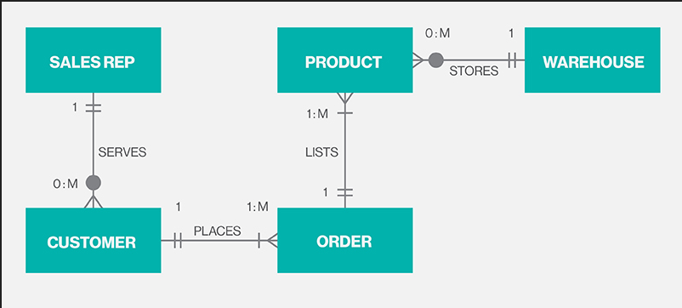

Fig. ER Diagram.

1. Define entity and give an example.

Entity is any real world object that have an attribute. We can take any object as an entity.

Employee, office, Person etc are the example of an entity.

3. Explain the different between an entity class and an entity instance.

4. Define attribute and its types.

5. What is derived attributes?

6. Define relationship and give an example.

7. Explain the difference between a relationship class and a relationship instance.

8. Define degree of relationship.

9. List and give an example of the three types of binary relationships. Draw an E-R diagram

for each.

10. Define the terms maximum cardinality and minimum cardinality.

11. Explain the distinctions among the terms primary key, candidate key and super key.

12. What are the main building modules of the entity relationship model? Discuss each one.

13. What is composite attributes, when it is used?

14. Explain the difference between single-value attributes and simple attributes.

15. Discuss the difference between a composite key and a composite attribute. How would

each indicated in an E-R diagram?

16. What two courses of action are available to a designer when a multivalued attribute is

encountered?

17. Explain the various terms of an E-R model and how are they represented in an E-R

model?

18. Explain the concept of dependent entities? Give example.

19. What is the difference total and partial participation? Explain.

20. What do you mean by mapping cardinalities? Explain various type of cardinalities.

21. What is the difference between single-value and multivalued attributes? Explain

22. Explain the concept of participation constraints.

23. Difference the binary relationship with ternary relationship with example.

24. Explain the difference between weak and strong entity set.

|  |  |
| --- | --- |
| Weak Entity | Strong Entity |
| The relationship between two strong entity set is represented by a double diamond symbol. | The relationship between two strong entity set is represented by a single diamond symbol. |
| The line connecting strong entity set with the relationship is double. | The line connecting strong entity set with the relationship is single. |
| Member of a weak entity set is a subordinate entity. | Member of a strong entity set is a dominant entity. |
| It is represented by a double rectangle. e primary key of a weak entity is found by taking the primary key of the strong entity on which it is existence-dependent, plus the discriminator of the weak entity set. | It has its own primary key and it is represented by a rectangle. |

25. Define the components of extended E-R features.

* **Specialization**: It is a top-down approach in which one higher level entity can be broken down into two lower level entities.
* **Generalization:** Here the design process takes place in bottom up manner. Multiple entity sets are synthesized into a higher level entity set on the basis of common features.

Example: Employee and Customer entities can be synthesized into a higher level entity Person.

* **Attribute Inheritance:** The attributes of higher level entity set are inherited by lower level entity set.
* **Aggregation:** Aggregation is an abstraction in which relationship sets are treated as higher level entity sets. Here a relationship set is embedded inside an entity set, and these entity sets can participate in relationships.

26. Define the concept of aggregation. Give two examples of where this concept is useful.

Data aggregation is any process in which information is expressed in a summary form for purposes such as reporting or analysis. Ineffective data aggregation is currently a major component that limits query performance. And, with up to 90 percent of all reports containing aggregate information, it becomes clear why proactively implementing an aggregation solution can generate significant performance benefits, opening up the opportunity for companies to enhance their organizations’ analysis and reporting capabilities.

This concept is mainly used in Bank and Hospital.

27. Explain the distinction between disjoint and overlapping constraints.

**Disjoint:**

In a disjoint design constraint, an entity can be almost one of the subclasses of the specialization. i.e. Employee is disjoint to secretery,technician,engineer .

**Overlapping:**

On the other hand, overlapping gen are revert in the sense that the super class can belong to more than one subclass. for eg: person as a super class and passport, driving license as its overlapping subclass.

28. Explain the distinction between total and partial constraints.

**Total Constrains:**

* If an entity can exist, only if it participates in at least one relationship instance, then that is called total participation, meaning that every entity in one set, must be related to at least one entity in a designated entity set.
* An example would be the Employee and Department relationship. If company policy states that every employee must work for a department, then an employee can exist only if it participates in at least one relationship instance (i.e. an employee can’t exist without a department)
* It is also sometimes called an existence dependency.
* Total participation is represented by a double line, going from the relationship to the dependent entity.

**Partial**:

* If only a part of the set of entities participate in a relationship, then it is called partial participation.
* Using the Company example, every employee will not be a manager of a department, so the participation of an employee in the “Manages” relationship is partial.
* Partial participation is represented by a single line.

.

29. Write short notes on:

· **Specialization**

It is opposite to Generalization. It is a top-down approach in which one higher level entity can be broken down into two lower level entity. In specialization, some higher level entities may not have lower-level entity sets at all.

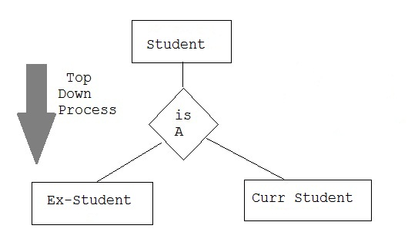

· **Generalization**

It is a bottom-up approach in which two lower level entities combine to form a higher level entity. In generalization, the higher level entity can also combine with other lower level entity to make further higher level entity.

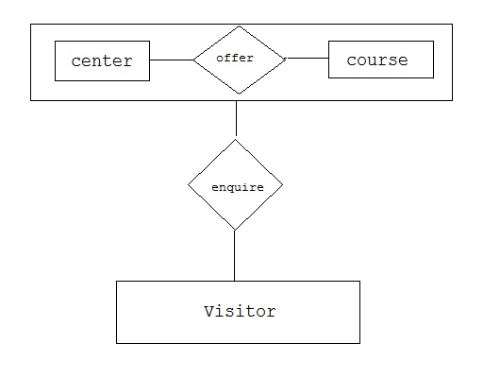

**· Aggregation**

It is a process when relation between two entity is treated as a single entity. Here the relation between Center and Course, is acting as an Entity in relation with Visitor.

